GetThisBread

Project Team Members:

Richard Abrams

Ronald Abrams

Emily Ashburn

Michael Calvo

Jason Manning

Ian Wilhelmsen

Table of Contents

**1. Project Definition**

**2. Project Requirements**

Functional

Usability

Performance

System

Hardware Specifications

Software

Security

**3. Project Specification**

Focus / Domain / Area

Libraries / Frameworks / Development Environment

Platform

Genre

**4. System – Design Perspective**

Design Choices

Identifying Subsystems

**Database Subsystem**

ER Diagram

UML Diagram

**Inventory Subsystem**

Use Case diagram:

UML Diagram

Class Diagram

**Login Subsystem**

Use Case Diagram

UML Diagram

Class Diagram

**PoS Subsystem**

Use Case Diagram

UML Diagram

Class Diagram

**Scheduling Subsystem**

Use-case diagram:

UML Diagram

Class Diagram

Sub-System Communication (Diagram and Description)

Control Diagram

I/O - Communication between Subsystems:

Data Flow Diagrams:

Entity-Relationship Model (E-R Model)

System Model

System Interaction Sample 1:

System Interaction Sample 2:

**5. System – Analysis Perspective**

System (Tables and Description)

Process Model:

Algorithm Analysis

Data dictionary

**6. Project Scrum Report**

Product Backlog

**7. Subsystems**

**7.1 Database Subsystem – Ian Wilhelmsen**

Design and model

Previous Entity-Relationship Model (E-R Model):

Finalized Entity-Relationship Model (E-R Model):

UML Diagram

Design choices

Data dictionary

Coding

Approach (Functional, OOP)

Language

User training

Testing

**7.2 Inventory Subsystem – Richard Abrams**

Design and model

Use Case Diagram

Design choices

Data dictionary

Coding

Approach (Functional, OOP)

Language

**7.3 Login Subsystem – Mike Calvo and Ronald Abrams**

Design and model

Use Case Diagram

UML Diagram

Class Diagram

Design choices

Data dictionary

Coding

Approach (Functional, OOP)

Language

User training

Training / User manual (needed for final report)

Testing

**7.4 Point of Sales Subsystem – Emily Ashburn**

Design and model

Use Case Diagram

ER Model

Design choices

Data dictionary

Coding

Approach (Functional, OOP)

Language

User training

Training / User manual

Testing

**7.5 Scheduling Subsystem – Jason Manning**

Design and model

Use Case Diagram

Class Diagram

Data dictionary

Coding

Approach (Functional, OOP)

Language

User training

Training / User manual (needed for final report)

**8. Complete System**

Final software/hardware product

Source code and user manual – screenshots as needed - Technical report

Evaluation by client and instructor

Team Member Descriptions

Richard Abrams

Ronald Abrams

Emily Ashburn

Mike Calvo

Jason Manning

Ian Wilhelmsen

# 

# 

# 

# 

# 1. Project Definition

The project GetThisBread is needed in the industry by small businesses like diners, beauty salons, web-only storefronts, and whole hosts of businesses to direct the workflows of their employees and keep track of stock, product, and profit.

This goal will be achieved by creating subsystems, featuring Point of Sales (POS), Timesheet Management System (TMS), Business Intelligence Analysis (BIA), Inventory Management (IM), all supported by a robust API which will all utilize Angular, Bootstrap, PHP and MySQL.

# 

# 2. Project Requirements

## 

## Functional

The application is planned to have the following functional requirements: Be readily available for many different types of end-users of a variety of roles managed by Google’s SSO. The application will support a Timecard Management System (TMS). The TMS will support features such as allowing employees to clock in and out of their appropriate jobs. The TMS will also support the scheduling of employees by role at a location and support the viewing of schedules. The application will support a Point of Sales System (POS). The POS will allow orders to be placed and track transactions. By tracking transactions, the POS subsystem will keep information on both credit transactions handled by a third party and cash transactions. The POS will support ticket/order viewing. The POS subsystem will also support the end-of-business day processing. The application will feature a Business Intelligence Analysis (BIA) which in turn will track business-specific high dimension data and display that information for principles. The BIA information will present this information to inform users concerning profit, minimum profit point, days until business failure, the average cost of ingredients per recipe, and a four-quadrant plot for rating items based on their sales and profit margin. Lastly, the application will act as an Inventory Management System (IMS). The IMS will keep track of incoming stock, items sold, inventory audits, creation/deletion of items, recipe costing, and estimation of utilization.

## 

## Usability

The user interface will be a web browser (preferably chrome). The team will make use of javascript libraries and UI libraries to render action and information panels to assist in point of sale operations, time scheduling, inventory management, and business analytics. Additional libraries will be used to better support the needs of disabled or impaired users and their ease of access. The application will accomplish this by using many views with similar formatting separating key functionality of the application with clear chaining that is driving a user to complete their workflow with the least amount of scrolling, and searching and scanning the screen for their objective. The views will maintain a relatively homogenous and intuitive layout; creating as little clutter or “noise” as possible.

### Performance

This application deals with real-time inventory, finances, and cash-specific transactions. The demand for these services is not 24hrs for all users at the same time. While the application must be accurate all the time it is in use, the application will have downtime for certain users and, at worst, expected outages of service can be arranged. The application must be accurate every time for its POS functions but there can be grace periods when dealing with the inventory or TMS functionality. Errors and continual rollouts for business-specific functionality for the TMS and IMS can be addressed with less urgency than an outage of order taking at a restaurant. Time management changes or inventory audits can be managed with pen and paper or attempted later after a hotfix.

## 

## System

### Hardware Specifications

Principles would be interested in hosting the application on a VM on either a cloud or through a self-hosted farm. An MS Server 2016 or 2019 hosting a farm on Hyper-V or a centOS hosting VMWare or spinning individual VMs up via AWS or Red Hat would be enough to host the web server and DBMS given that a 100GB drive, i5 Intel 8th, a standard nic and 16 GB of SO-DIMM DDR4. The physical requirements are the equivalent of a mid-level NUC or any other brand name entry-level mini-workstation. Image snapshots, DB backups, and event logs should be stored in another location. These low-end solutions should last 5 years speculatively.

## 

### Software

The application system level can be hosted on MS server 2016 or better, CentOS 7 or Ubuntu Server 20.4. The application’s web server should match the preference of the client’s choice of an operating system. IIS should be used for MS server installations as WAMP or Apache should be used for Linux installations.

Database

This application is being built using MySQL. MySQL is preferred because it excels at online transactions out of the box on the community level. When more transaction capacity is required and the need for analytics to be separated from the business domain and operate on a separate server; additional features available from other Enterprise level DBMS should be considered.

## Security

While in development, the application will have no security requirements. When this application becomes a production instance it will need role-based login through Google LDAP and SSO Service, SSL/TLS certificates, separation of the web server and DBMS, and secure encryption between the two preferably, encrypted tables for any sensitive information recorded from credit transactions.

# 3. Project Specification

## Focus / Domain / Area

GetThisBread has the focus on delivering an easy to use point of sale and timecard management systems for businesses that require it. In addition, to better serve those businesses, we added inventory management.

## Libraries / Frameworks / Development Environment

In order to accomplish those goals, our team intends to use a variety of tools to build GetThisBread. Firstly for the UI side, we will be using Figma to storyboard and figure out the layout of the UI. The front end will actually be built using Angular. For the back-end, various other tools will be included. The language intended to be used is PHP for the models and MySQL for the database.

## Platform

As a web application, the focus is on allowing users to run it in a browser. The target is that if anyone has a device that can run Chrome, Edge, or Firefox such as a laptop or smartphone, it would be possible to run GetThisBread. Our expected libraries and development environments to develop GetThisBread will be WAMP, PHP 7.4.12, MySQL 8.0.22, VS Code, Eclipse, and Angular.

## Genre

The genre of the project is a web application with a database.

# 4. System – Design Perspective

*Identify subsystems – design point of view*

## Design Choices

The application will follow a mostly MVC and CRUD style for the bulk of the application. The advantages of this choice are clearly reusability and ease of onboarding one teammate from one component to another. Additionally, utilizing reflective class functions to minimize the amount of coding needed to access the database. The database will not follow a conventional normalization but instead, rely heavily on lookup tables and mirror the CRUD operations of the application.

## Identifying Subsystems

The model and data collection subsystem, referred to as the back end, will be responsible for storing data, serving up the data back in the form of models and housing the AJAX API that will support the asynchronous calls of the rest of the subsystems.

The Point of Sales subsystem will be a collection of views that fulfills all of the features laid out for the POS. The POS will pull models and data from those models from the back end.

The Timecard Management subsystem will be another collection of views that support the features of the TMS.

The Inventory Management subsystem will be a collection of views that support the features of the IMS.

The Business Intelligence Analysis subsystem will be a collection of views that pull data and display it in various formats. At the moment, this subsystem is planned with little transformation of data.

The Login subsystem will be a verification of both authentication and belonging to a particular organizational unit within the Google Directory of that “store.” The system will also be responsible for maintaining the identity of the user throughout their session in the application.

### Database Subsystem

#### ER Diagram

#### UML Diagram

#### 

### Inventory Subsystem

#### Use Case diagram:

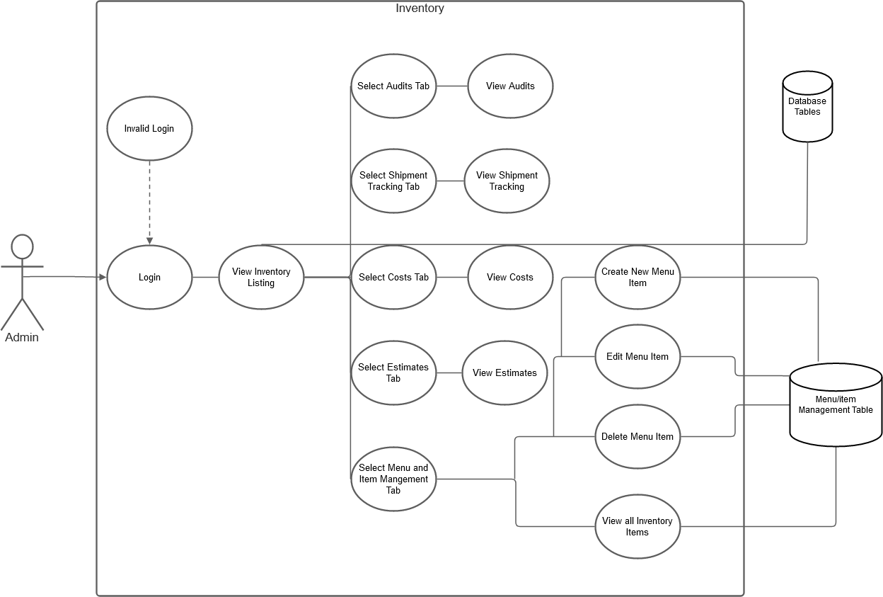

The above diagram is a use case example of using the inventory system in GetThisBread. After the admin logs in, they would be able to navigate to the inventory. From there the admin would be able to navigate to view audits, track shipments, view costs, and view estimates all of which would need to pull data from the database. In addition, the admin would be able to modify the menu from the inventory by being able to add, modify, and delete items in the menu which will update the relevant table in the database. Lastly, a comprehensive inventory list can be viewed from the inventory management section.

#### UML Diagram

#### Class Diagram

### Login Subsystem

#### Use Case Diagram

#### UML Diagram

#### Class Diagram

### PoS Subsystem

#### Use Case Diagram

#### UML Diagram

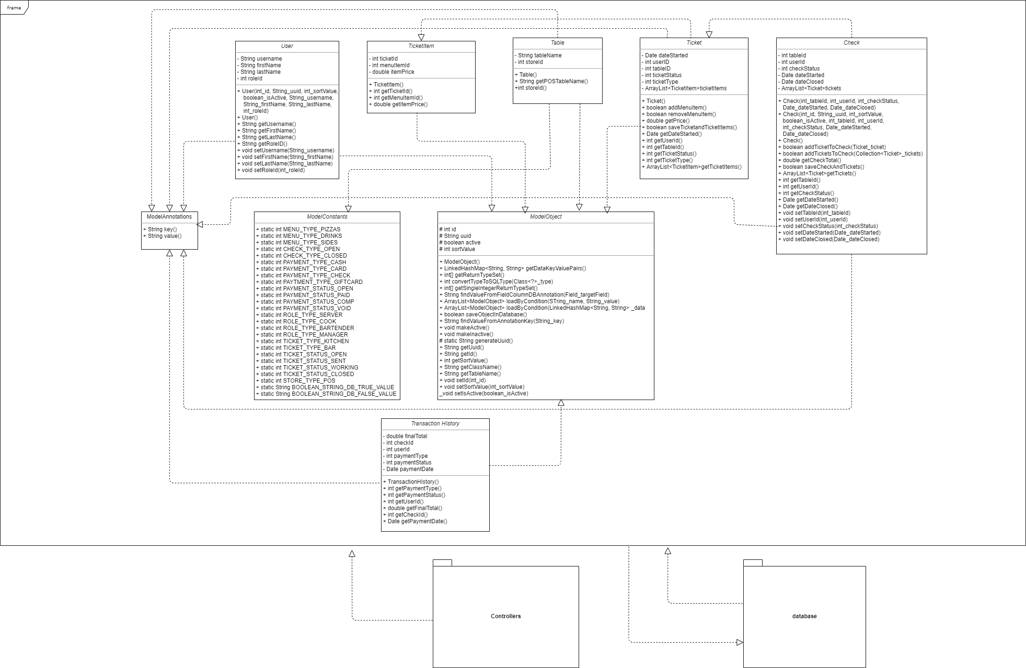

#### Class Diagram

### Scheduling Subsystem

#### Use-case diagram:

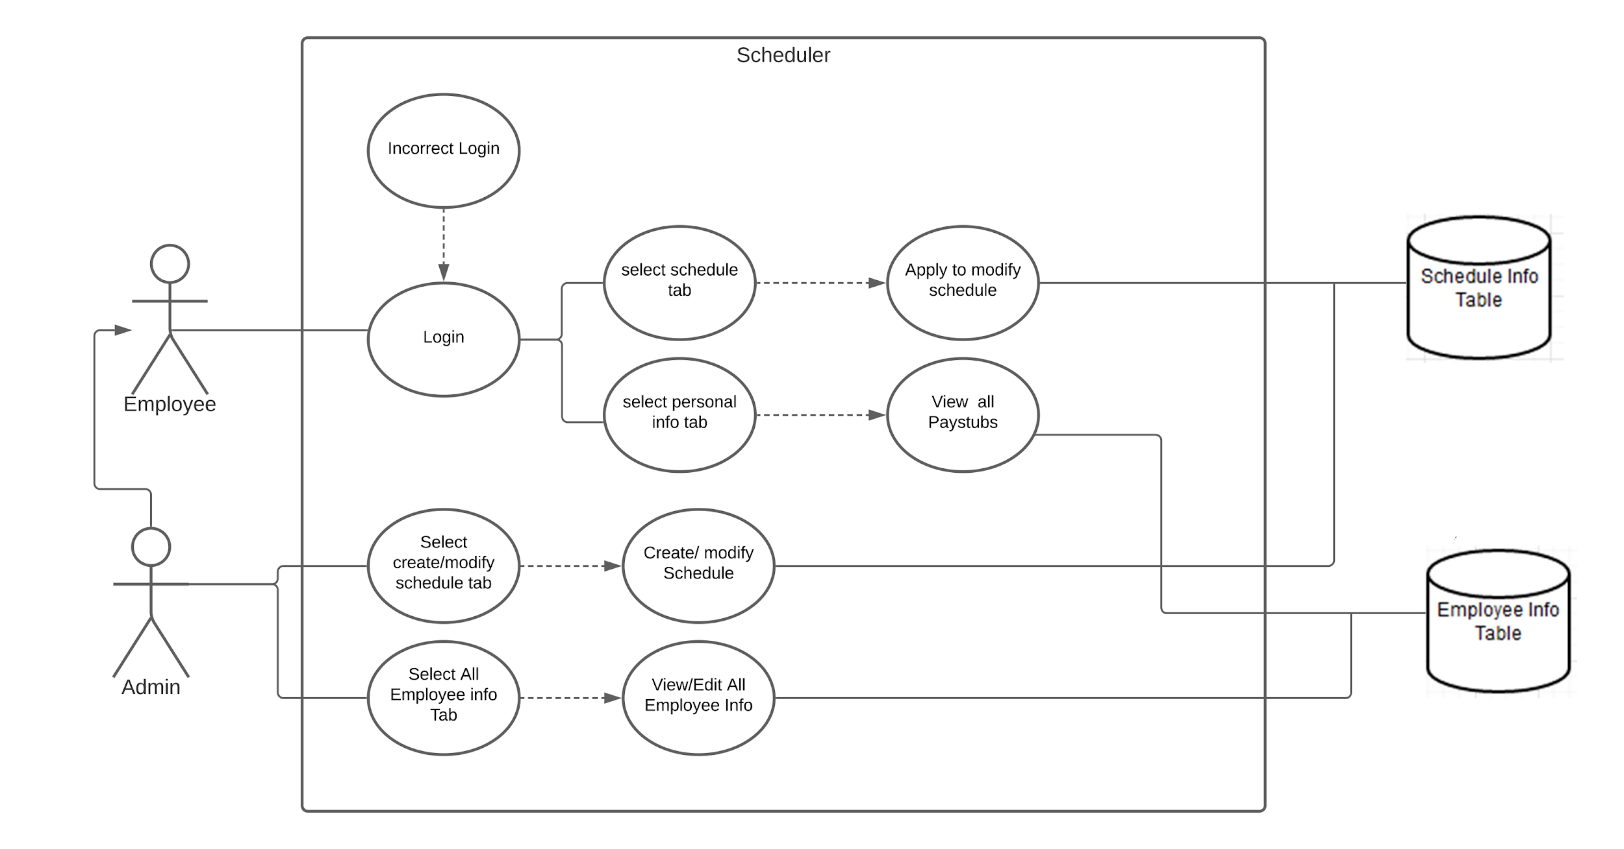

The above diagram is a use case example of using the scheduler system in GetThisBread. It starts with a user or admin logging in. At that point, an employee can either look at their personal info which pulls data from the employee info data in our database, or update their schedule which will push out a request to the database. If you are an admin in addition to the employee’s capabilities, you can also navigate to modify other employees’ data and adjust the schedule which will update the relevant tables in the database.

#### UML Diagram

#### Class Diagram

## Sub-System Communication (Diagram and Description)

## 

### Control Diagram

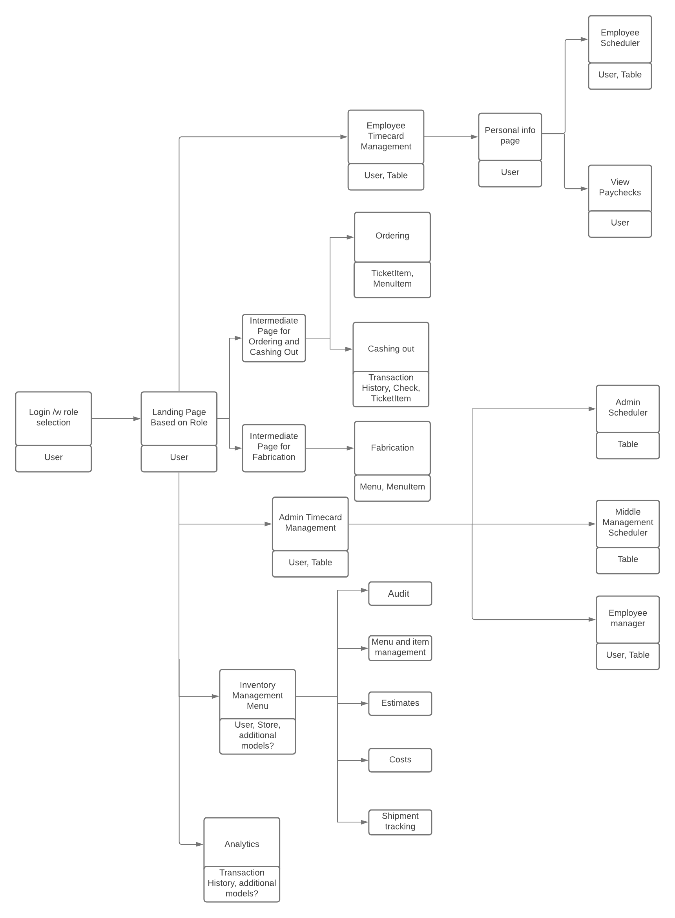

The above diagram is an example of a control diagram for GetThisBread. The diagram shows a general idea of the current assumed flow of views and models needed for the various functional elements. The idea is to start at a login page and then have subsequent access to various other tabs and panels as necessary. From the landing page, each branch out can be considered a subsystem with the following views and models being parts of those subsystems. Lastly, the diagram also communicates the flow of expected control for those subsystems.

## I/O - Communication between Subsystems:

Users (Managers, Employees), Google API, and the SQL Database independently request and receive information from the main GetThisBread system as shown within the context diagram. This is done with Ajax calls to subsystems. These calls hit the backend API and serve the data in JSON format using predefined models. Upon return, the process is reversed.

## Data Flow Diagrams:

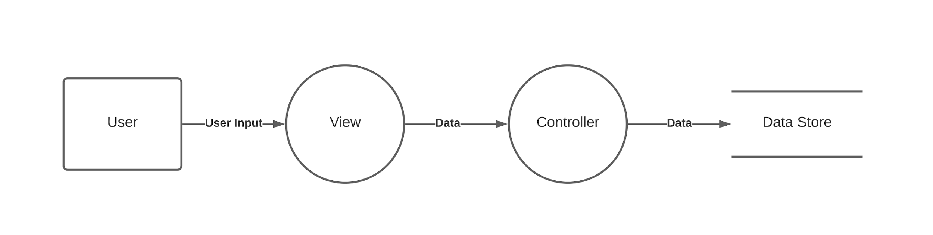

The above sample diagram shows the expected flow of data for user input in GetThisBread. It is a simple setup with the user inputting data into a view after which it passes it on the controller and then finally to the database for storage.

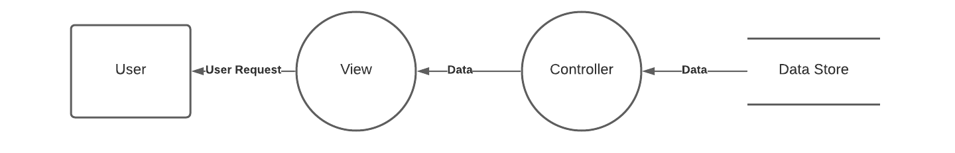

The above sample diagram shows the expected flow of data for a user request. A user makes a request and data is pulled up to the view from the database to display to the user.

## Entity-Relationship Model (E-R Model)

The initial ER diagram of our database.

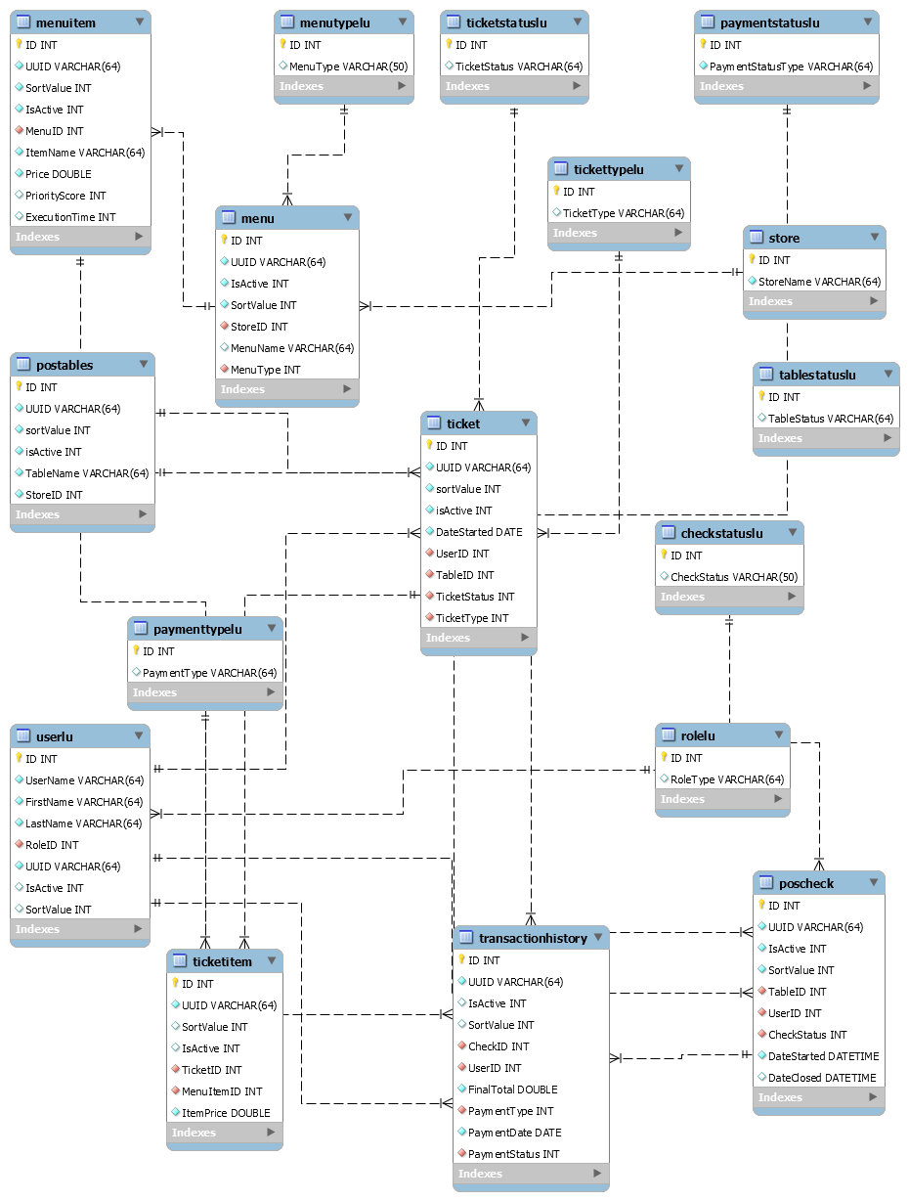

The above entity-relationship diagram was created using the existing MySQL database. This diagram highlights the primary and foreign key relationships within the models in the PoS subsystem.

## System Model

### System Interaction Sample 1:

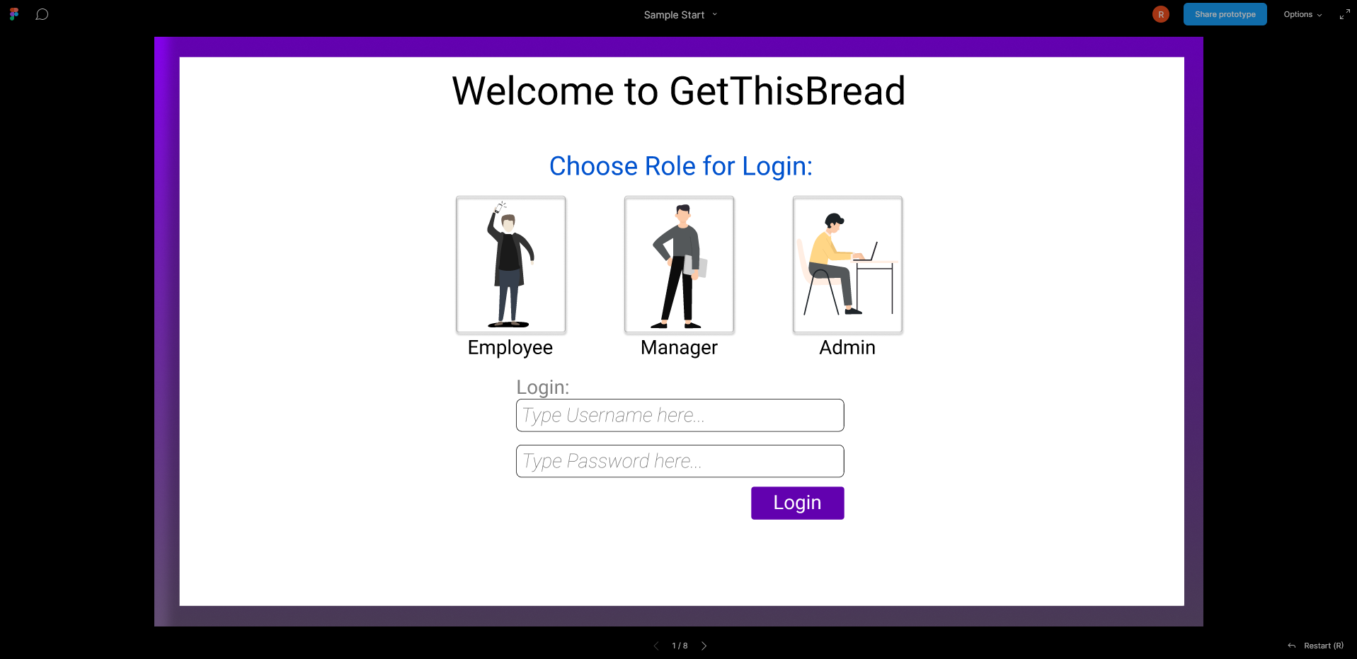

The above sample shows an example of the expected login page. It would tie into the login system.

### System Interaction Sample 2:

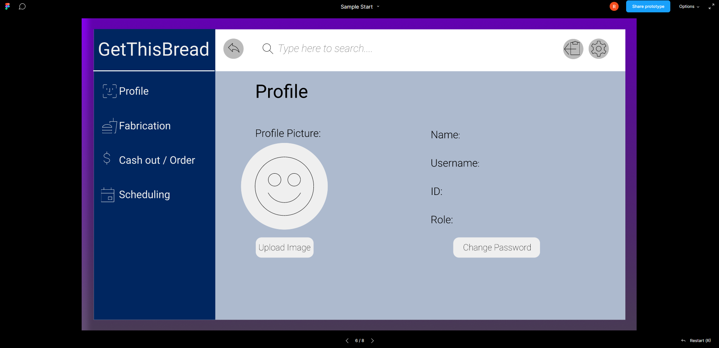

The above sample is an example of the expected landing page. It is an early prototype and would serve as a connection to all the other views and subsystems in GetThisBread

# 5. System – Analysis Perspective

*Identify subsystems – analysis point of view*

## System (Tables and Description)

## Process Model:

Our team has decided to develop code in Agile based on several key factors. Our requirements document is a living document that is continuously updated. Items are being refactored and new discoveries are being made every day to make this application better. Constant discussion about the nature and spirit of the requirements is a constant topic at all our meetings.

## Algorithm Analysis

Analysis of Subsystems and Subsystem Algorithm Analysis:

For purposes of this section, we are going to divide the subsystems into 3 families: data transforming front end subsystems, back end subsystems, and data displaying front end subsystems. The back end subsystems maintain state and provide data to the views and determine the time complexity of the other two families of the application. The login subsystem works in relative linear time, if not constant. The login subsystem fetches the authentication of a user and maintains session details. A large portion of the time complexity is derived from the database subsystem. The database will be organized such that extracting data will be stacked with one-to-many rows. An example being, extracting the items offered by one location could be as time-consuming as using a store ID to find all menu IDs of that store then menuItems of that menu. This process is polynomial-time but by using a store-specific configuration file and creating a series of global variables the time could be shortened to nlog(n).

The other two families of subsystems, written mostly in angular, are going to be initialized partly by the webserver in constant time. The web server will serve up html for initial consumption but portions will later be altered as the page comes live from ajax calls made to the backend subsystem. For instance, a display of all drinks offered at a bar will come up in constant time relative to the time the backend subsystem brought up the view, models, and data for that particular page. However, some pages will require an ajax call to populate a table, fill out the forms or assemble lists. Since the bulk of the process is carried out on the web server via the ajax call we can express this time complexity as linear.

## Data dictionary

For the tables below, PK = primary key, FK = foreign key

# 6. Project Scrum Report

## Product Backlog

|  |  |  |  |  |
| --- | --- | --- | --- | --- |
| Task Name | Owners | EE | PE | Status |
| Database table creation | Ian | 20 | 40 | DONE |
| Log In Google SSO | Mike/Ronald | 10 | 10 | Done |
| Log in Chooses Role | Mike/Ronald | 10 | 10 | WIP |
| Log in Changes Navigation | Mike/Ronald | 10 | 10 | WIP |
| Log in API call for Roles | Mike/Ronald | 10 | 10 | WIP |
| Log in Persists | Mike/Ronald | 10 | 10 | WIP |
| Inventory Models | Group | 10 | 20 | Done |
| Schedule Models | Group | 10 | 20 | Done |
| Log in views | Mike/Ronald | 10 | 10 | Done |
| Create schedule view | Jason | 20 | 40 | WIP |
| Schedule API calls | Jason | 40 | 80 | WIP |
| Inventory View | Richard | 40 | 80 | Done |
| Inventory Controller | Richard | 40 | 120 | WIP |
| Schedule Controller | Jason | 40 | 120 | WIP |
| Database stored procedures | Ian | 20 | 80 | Done |
| Database Seed/LU/Funcs | Ian | 20 | 80 | Done |
| API file | Ian | 10 | 10 | Done |
| API Utility Class | Ian | 10 | 10 | Done |
| Database Classes | Ian | 20 | 20 | Done |
| DB scripts | Ian | 5 | 5 | Done |
| POS views | Emily | 20 | 40 | WIP |
| POS Controller | Emily/Ian | 20 | 40 | WIP |
| Report 1 Draft | Group | 20 | 40 | DONE |
| Report 1 Finalized | Emily/Ian | 5 | 10 | DONE |
| Report 2 Draft | Group | 20 | 40 | Done |
| Report 3 Draft | Group | 20 | 40 | Done |
| Report 2 Finalized | Emily/Ian | 5 | 10 | Done |
| Report 3 Finalized | Emily/Ian | 5 | 10 | Done |
| Slides 1 | Group | 10 | 10 | Done |
| Slides 2 | Group | 10 | 10 | Done |
| Slides 3 | Group | 10 | 10 | Done |
| Poster Draft | Group | 10 | 10 | WIP |
| Poster Final | Emily/Ian | 10 | 10 | WIP |

## 

# 7. Subsystems

# 7.1 Database Subsystem – Ian Wilhelmsen

## Design and model

### Previous Entity-Relationship Model (E-R Model):



### Finalized Entity-Relationship Model (E-R Model):

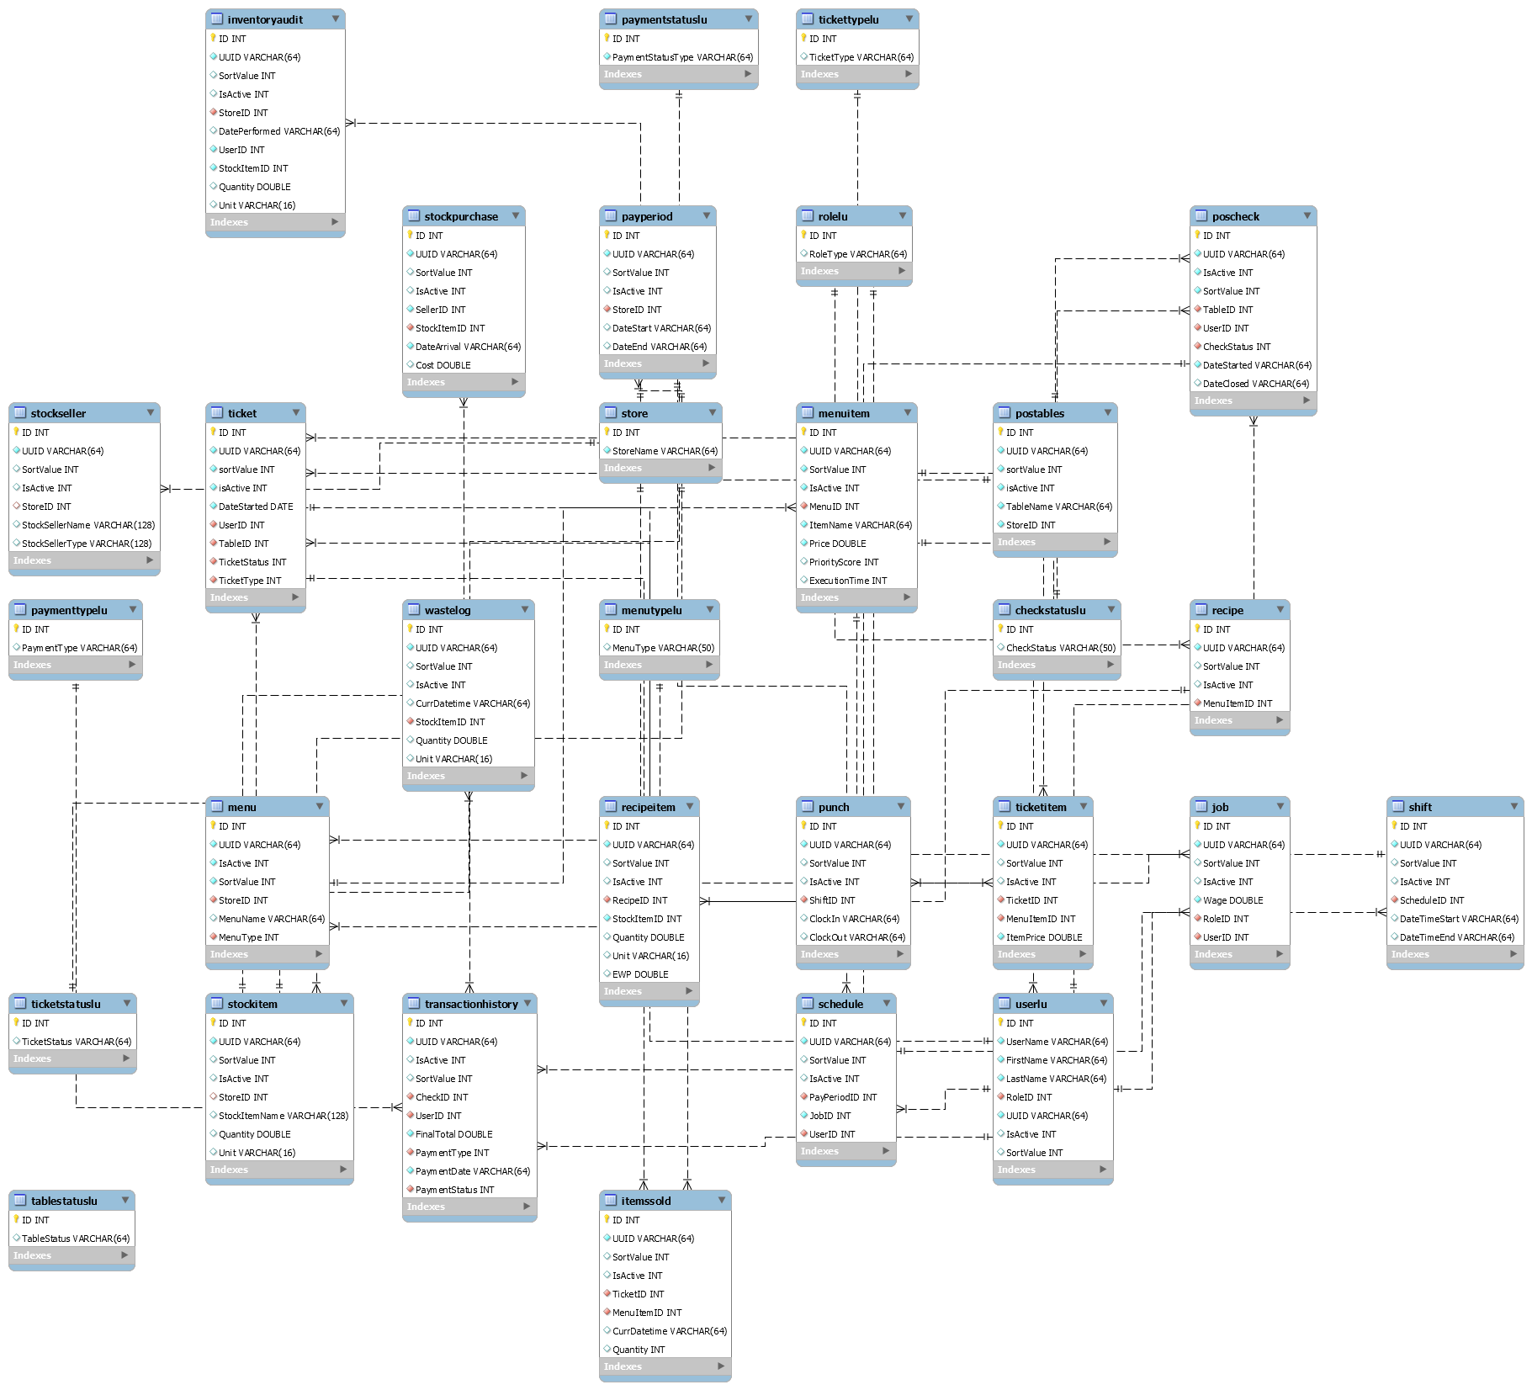

### UML Diagram

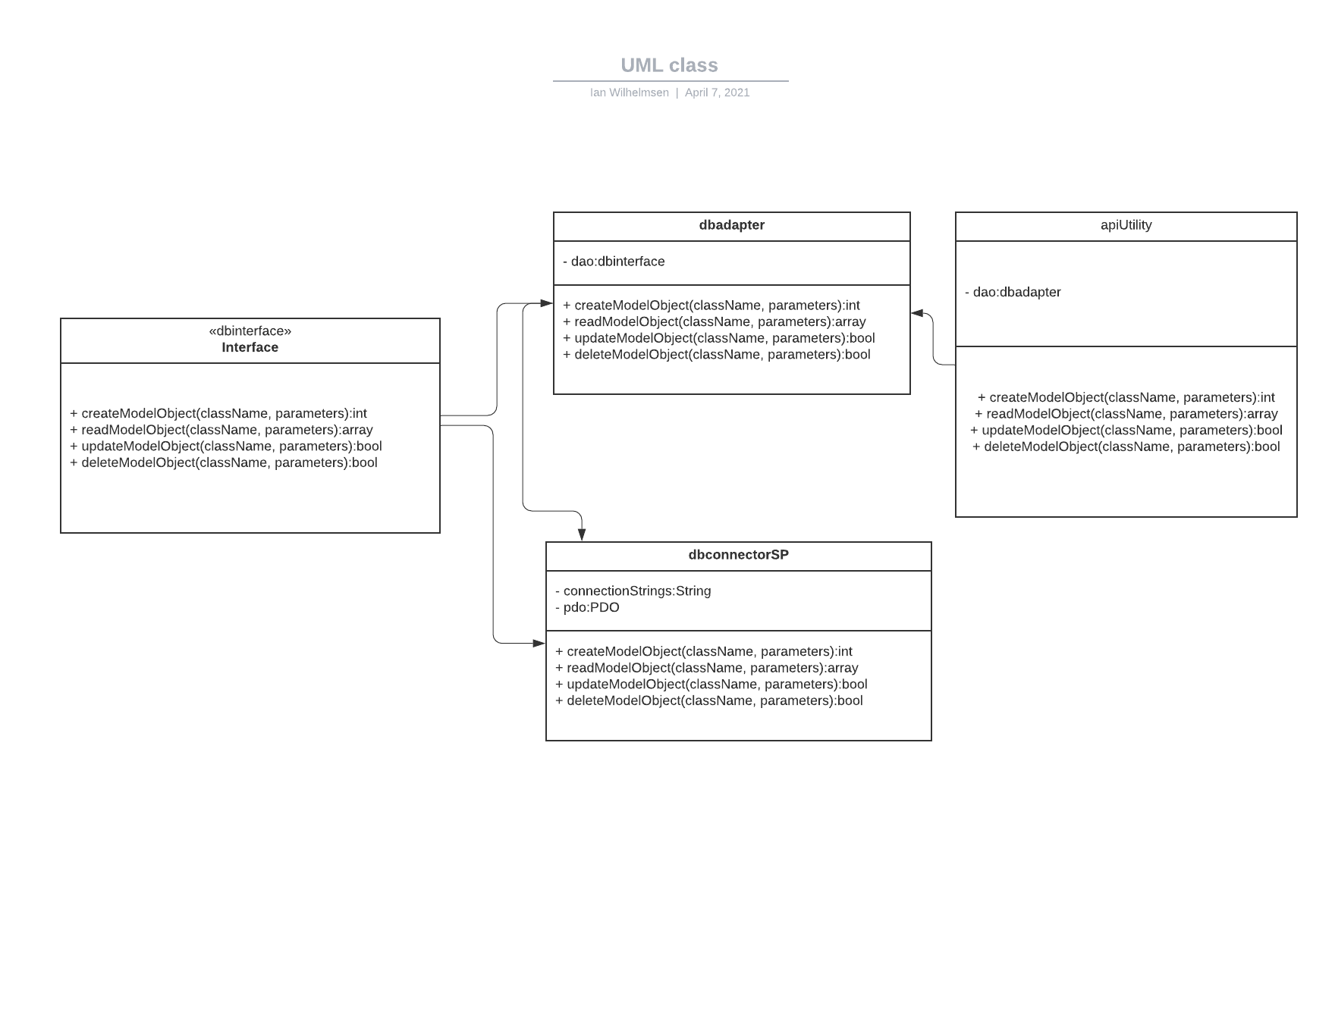

### Design choices

I decided on a purely functional simplified API. Instead of supporting many pages and expanding skeleton architecture, all requests are funnelled into a few functions that reflectively handle all data. Furthering the design would include making more models that handle error checking reflectively and produce conditions to pull or push data into the database.

## Data dictionary

As the backend of the entire application and its subsystems, this subsystem supports all the models of all the other subsystems.

If refined (changed over the course of the project)

The design of this subsystem changed over the course of this project significantly. Models were added, subsystems were flushed out and the shape of the database was changed. Many of the subsystems did not finalize their versions of models or establish the parameters needed until very recently. This was expected as we are developing on an agile concept. The team constantly betters the design and the backend needed to support these changes.

The cost of this flexibility is error checking. In a perfect world, the back end would handle error checking in addition to the ETL functions it needs to. This is still possible. Reflexive model based error checking can still be included. Another issue is that in future load balancing cannot be supported programmatically. At the most load balancing can only take place on the web server or at the physical level. The way to handle this would be to adopt a more distributed API file structure but that would mostly come after the application becomes fully established. If the final structure of the application flushes out, both of these features can be added and more security can be added to the application.

The model analysis has not changed for the backend. The backend API portion still operates on linear time. The database handles retrieving and all O(n2) operations. Due to our choice to use only CRUD operations, all of our operations are linear time except read operations. Reads are still returns of foriegn key restrained rows that are active for the application. The design can stand as it is for now. Later releases would need to completely change end points of API or significantly reroute traffic.

## Coding

### Approach (Functional, OOP)

The approach taken is a functional object oriented approach. The subsystem receives a request to the API which spins up an apiUtility class to arrange the hand-off of parameters and retrieval of data from the Database Access Object. That object directly talks with the database through prepared statements calling stored procedures with credentials to only execute things on the database. The return is evaluated and then json encoded before being sent back as a response to the caller.

### Language

This subsystem used PHP, SQL, and a small amount of T-SQL.

## User training

This portion of the application has no training or user manual for its use. Additions, updates or changes in this functionality should be handled by a development team or single software developer to gather new requirements and features from the stakeholders and then begin work. There is no reason for a lay person to explore this subsystem.

## Testing

Testing can be accomplished by running a series of inputs in an api tester freely available. Preferably, Postman, a free to use application can be used for unit and integration testing. Postman can be programmed for a series of requests to supply and will check inputs.

---------------------------------------------------------------------------------------------------------------------

# 

# 7.2 Inventory Subsystem – Richard Abrams

## Design and model

### Use Case Diagram



The above diagram was the original intended use case diagram for the inventory subsystem.

As the project has progressed, various changes have been made to how the subsystem functions. The most prominent change from the user perspective is that the navigation bar is much more of a focus removing the potential need for a dedicated inventory landing page. In addition, there have been some table modifications to handle the various use cases more efficiently. Lastly, one of our plans is to move away from vanilla HTML to something more robust such as JQWidgets or Bootstrap.

The pros of these changes include an easier navigation experience for the user in specific uses cases, such as inventory listing. The table modifications provide all the data required to handle the potential use cases. Additionally, a move to JQWidgets or Bootstrap would allow us to upgrade the look of the HTML list and form to fit a stylized and simple look to further ease the creation of new pages.

The cons of these changes mainly rest with the navigation bar reliance and the switch from HTML. Utilizing the navigation bar more will possibly make it look more obtuse and harder to use. For the HTML switch, there is a training turnaround period to get it setup. In addition, the views overhead will slightly increase and make it more expensive to run.

The changes in the model from the initial design are focused on allowing for a better setup for the new target use cases, which include displaying stock and menu items, addition and deletion of menu items, showing potential wastage, viewing an inventory audit, and tracking shipments. The new use case diagram for this subsystem can be seen below:

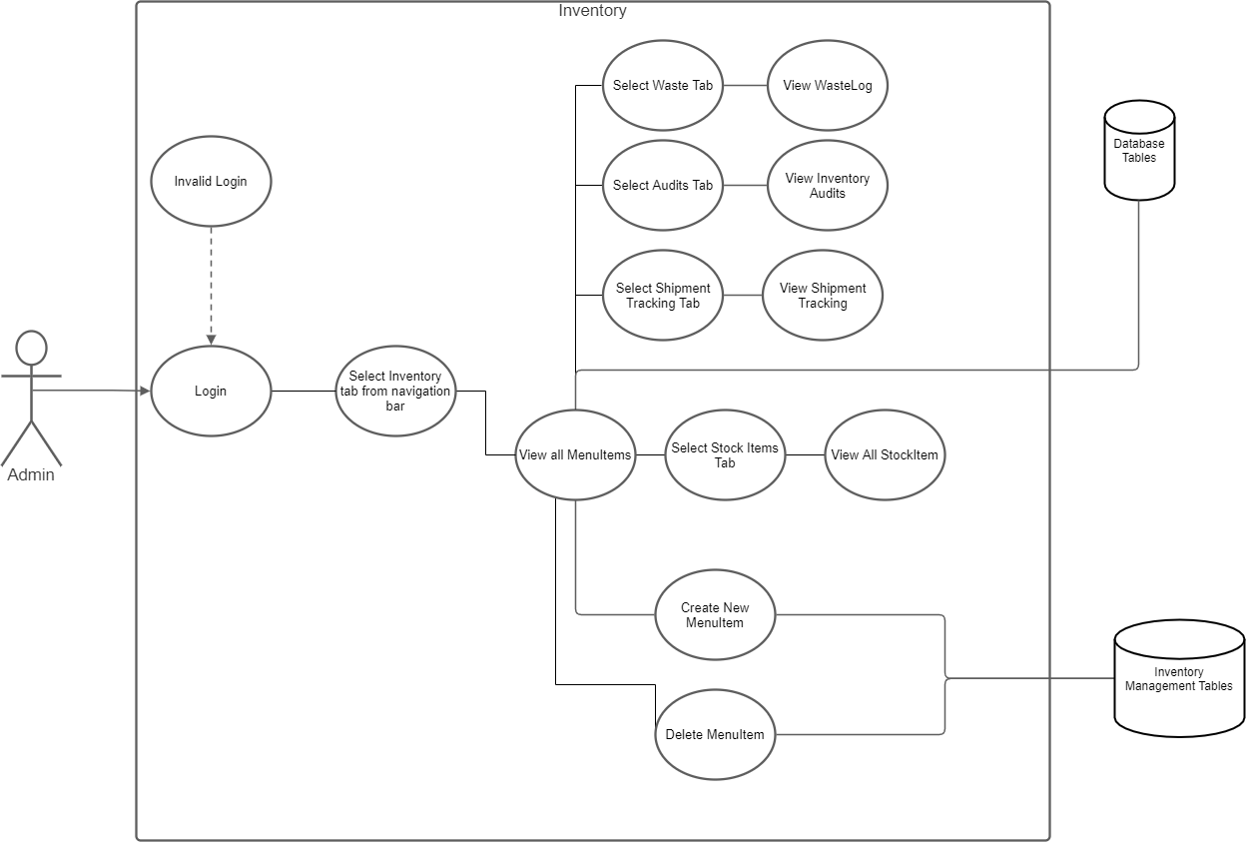

In the redone use case, if the changes are made the user will have an easier time to access certain features and is more in tune with the angular component structure.

### Design choices

From the initial design, it was intended from the login to an inventory landing page that would act as a portal to other parts of the inventory system such as viewing the entire inventory and audits. All relevant tables would be updated and pulled from. For the front end part of the system, Angular was utilized using TypeScript, HTML, and SCSS to accomplish view construction. A REST API is utilized for external communication.

### 

## Data dictionary

|  |  |  |
| --- | --- | --- |
| **“TABLE ASSOCIATION”** | **“VARIABLE NAME”** | **“DATA TYPE”** |
| "Store" | "ID" | "Int" |

|  |  |  |
| --- | --- | --- |
| **“TABLE ASSOCIATION”** | **“VARIABLE NAME”** | **“DATA TYPE”** |
| "ItemsSold" | "TicketID" | "Int" |
| "ItemsSold" | "MenuItemID" | "Int" |
| "ItemsSold" | "CurrDatetime" | "Int" |
| "ItemsSold" | "Quantity" | "Float" |

|  |  |  |
| --- | --- | --- |
| **“TABLE ASSOCIATION”** | **“VARIABLE NAME”** | **“DATA TYPE”** |
| "WasteLog" | "ID" | "Int" |
| "WasteLog" | "CurrDatetime" | "Int" |
| "WasteLog" | "StockItemID" | "Int" |
| "WasteLog" | "Quantity" | "Float" |
| "WasteLog" | "Unit" | "String" |

|  |  |  |
| --- | --- | --- |
| **“TABLE ASSOCIATION”** | **“VARIABLE NAME”** | **“DATA TYPE”** |
| "Recipe" | "MenuItemID" | "Int" |
| "Recipe" | "ID" | "Int" |

|  |  |  |
| --- | --- | --- |
| **“TABLE ASSOCIATION”** | **“VARIABLE NAME”** | **“DATA TYPE”** |
| "RecipeItem" | "RecipeID" | "Int" |
| "RecipeItem" | "StockItemID" | "Int" |
| "RecipeItem" | "Quantity" | "Float" |
| "RecipeItem" | "Unit" | "String" |
| "RecipeItem" | "EWP" | "Float" |

|  |  |  |
| --- | --- | --- |
| **“TABLE ASSOCIATION”** | **“VARIABLE NAME”** | **“DATA TYPE”** |
| "StockItem" | "ID" | "Int" |
| "StockItem" | “StoreID" | "Int" |
| "StockItem" | "StockItemName" | "String" |
| "StockItem" | "Quantity" | "Float" |
| "StockItem" | "Unit" | "String" |

|  |  |  |
| --- | --- | --- |
| **“TABLE ASSOCIATION”** | **“VARIABLE NAME”** | **“DATA TYPE”** |
| "StockPurchase" | "ID" | "Int" |
| "StockPurchase" | "SellerID" | "Int" |
| "StockPurchase" | "StockItemID" | "Int" |
| "StockPurchase" | "DateArrival" | "Int" |
| "StockPurchase" | "Costs" | "Float" |

|  |  |  |
| --- | --- | --- |
| **“TABLE ASSOCIATION”** | **“VARIABLE NAME”** | **“DATA TYPE”** |
| "StockSeller" | "ID" | "Int" |
| "StockSeller" | "StoreID" | "Int" |
| "StockSeller" | "StockSellerName" | "String" |
| "StockSeller" | "StockSellerType" | "String" |

|  |  |  |
| --- | --- | --- |
| **“TABLE ASSOCIATION”** | **“VARIABLE NAME”** | **“DATA TYPE”** |
| "InventoryAudit" | "ID" | "Int" |
| "InventoryAudit" | "StoreID" | "Int" |
| "InventoryAudit" | "DatePerformed" | "Int" |
| "InventoryAudit" | "UserID" | "Int" |
| "InventoryAudit" | "StockItemID" | "Int" |
| "InventoryAudit" | "Unit" | "Float" |
| "InventoryAudit" | "Quantity" | "String" |

## Coding

The approach for the front end of the inventory system is utilizing Angular 11.2. By utilizing that version of Angular, it forces the use of TypeScript to support HTML and SCSS for view creation. In addition, the Angular framework is handled in discrete units called components. Each component represents a logical User Interface (UI) unit such as a navigation bar or an HTML list. Each component is defined by a TypeScript file, an HTML file, and in our case an SCSS file. In addition, each subsystem has a service that can make external calls utilizing the REST api.

### Approach (Functional, OOP)

The project baseline uses the Angular base template for a blank project. It includes base files to allow the Angular framework to run in addition to an app which serves as the start single page for Angular to work off of. From there within the app each front-end part of each subsystem is separated out into their respective folders. Each logical unit in Angular like a component or service receives its own folder to group the necessary files together. Each subsystem interacts with the app files to allow for navigation maintenance.

### Language

For the inventory, a separate inventory page component was created to serve as a navigation link for the app router within the project. The inventory component page also serves as a formatting unit for the layout of the inventory display as well as providing inventory specific styles. What comprises the main body of the inventory is the inventory list component. The inventory list component's main purpose is to serve as the view of an HTML list. It possesses various TypeScript lists to handle the information it displays. In the future, that task might be moved to another per entry component to allow for better styling. Lastly, it also sends requests to the inventory services which handles external communication.

## 

---------------------------------------------------------------------------------------------------------------------

# 7.3 Login Subsystem – Mike Calvo and Ronald Abrams

## Design and model

### Use Case Diagram

### 

### Design choices

The login subsystem will ultimately consist of one way to login, being a sign in from the Front-End to the Backend using Google’s Single Sign In to login. The way this login subsystem is going to work is that the client can make the request to see if it has a Google Account through Google Single Sign In, and if the client does, the Front-End will send a **POST** request or requests where required, which will be potentially because of whether the account is there in the SQL database or not, the Front End then using the information the client gets back from the SQL database. The rest of how this is handled is done by the Backend, which takes the information provided from the client, and sees if what is passed as a Username value matches an account in the SQL database.

## Data dictionary

|  |  |  |  |
| --- | --- | --- | --- |
| **“TABLE ASSOCIATION”** | **“VARIABLE NAME”** | **“DATA TYPE”** | **“DESCRIPTION”** |
| “RecordedUsers" | "IDUser" | "Int" | "This field is for "ID" that tracks each user." PK |
| “RecordedUsers” | “UUID” | “String” | “This field guarantees that a recognized “IDUser” also can be uniquely found no matter what.” PK |
| “RecordedUsers” | “FirstName” | “String” | “This field gives a given recognized “IDUser’s” “FirstName”.” |
| “RecordedUsers” | “LastName” | “String” | “This field gives a given recognized “IDUser’s” “LastName”.” |
| "RecordedUsers" | "UserName" | "String" | "This field gives the name for the given user." |
| "RecordedUsers" | "UserType" | "String" | "This field will determine if the user is a manager, worker, or admin." |
| "RecordedUsers" | "UserAuthorityLevel" | "Int" | "This is a value starting from 1 which goes up to show the level of access the user has." |

## Coding

### Approach (Functional, OOP)

The idea behind how this will happen with the Backend, is when the user logs in using the Google Single Sign In, a **POST** request is sent to the PHP Backend, which takes the Google Account’s email value parsed to just the name, and checks that against the SQL database, potentially creating an account in the SQL database if it does not have a matching value, or finding the account in the SQL database that is there with a matching Username.

### Language

An important thing to understand is that the **POST** from the Front-End actually goes to the basic CRUD operations in the Backend, and this is determined by a specifier in the json that is transferred from the Front-End to the Backend.

## User training

### Training / User manual (needed for final report)

Using the Login Subsystem relates Front-End Angular with the Backend PHP system. The Login Subsystem itself uses Firebase with the Front-End and makes **POST** or **POSTS** to the Backend by sending a matching Username to the database. A person should have a Firebase dedicated location in their code that returns a Google Account, and this should be stored and used to match a Username in the database. This should allow the Front-End to have access to a specific AuthorityLevel, and this value would then have to be stored to persist across the Front-End session. All points where the Front-End needs to decide what pages are visible would need to call this AuthorityLevel, and from what it has, this will decide which pages can be accessed.

## Testing

To confirm whether the login subsystem is working or not, the Front-End would need to login using the Google Single Sign In, and then send a **POST** request with a Username, going through the Backend to then potentially create an account in the SQL database if there isn’t one, or getting back the account and its “UserAuthorityLevel” if there does exists one. After this, the Front-End will display possible pages to click on that are based on the “UserAuthorityLevel”, meaning theoretically if there are different pages visible on the Front-End because a user is only an Employee rather than an Admin, these changes should be visible based on which user is logged in.

## 

---------------------------------------------------------------------------------------------------------------------

## 

# 7.4 Point of Sales Subsystem – Emily Ashburn

## Design and model

### Use Case Diagram

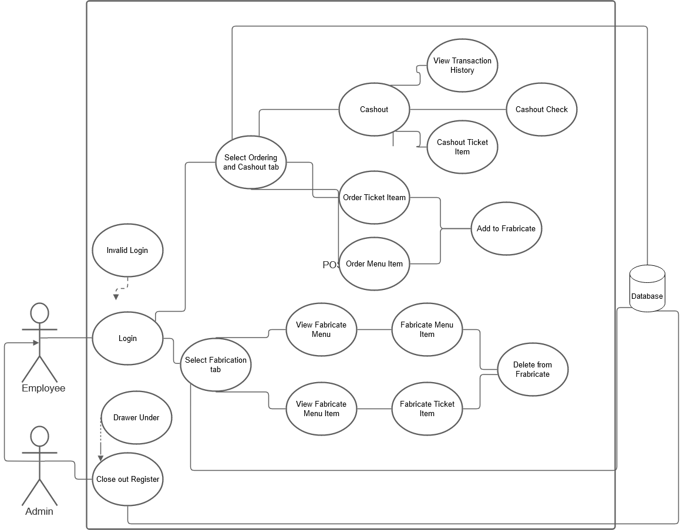

### ER Model



### Design choices

Some of the design choices made in this subsystem include the use of Bootstrap, HTML, CSS, and JavaScript instead of Angular.

Additionally, this subsystem will utilize the MVC structure principle in order to efficiently communicate back and forth with the database.

## Data dictionary

|  |  |  |  |  |  |  |
| --- | --- | --- | --- | --- | --- | --- |
| **Table** | **Field** | **Type** | **Nullable** | **Key** | **Default** | **Extra** |
| menu | ID | int | no | PK |  |  |
| menu | UUID | varchar | no |  |  |  |
| menu | IsActive | int | no |  |  |  |
| menu | SortValue | int | no |  |  |  |
| menu | StoreID | int | no | FK |  |  |
| menu | MenuName | varchar | no |  |  |  |
| menu | MenuType | int | no | FK |  |  |

|  |  |  |  |  |  |  |
| --- | --- | --- | --- | --- | --- | --- |
| **Table** | **Field** | **Type** | **Nullable** | **Key** | **Default** | **Extra** |
| menuitem | ID | int | NO | PRI | NULL | auto_increment |
| menuitem | UUID | varchar(64) | NO |  | NULL |  |
| menuitem | SortValue | int | NO |  | 0 |  |
| menuitem | IsActive | int | NO |  | 1 |  |
| menuitem | MenuID | int | NO | MUL | NULL |  |
| menuitem | ItemName | varchar(64) | NO |  | NULL |  |
| menuitem | Price | double | NO |  | NULL |  |
| menuitem | PriorityScore | int | YES |  | NULL |  |
| menuitem | ExecutionTime | int | YES |  | NULL |  |

|  |  |  |  |  |  |  |
| --- | --- | --- | --- | --- | --- | --- |
| **Table** | **Field** | **Type** | **Nullable** | **Key** | **Default** | **Extra** |
| menutypelu | ID | int | no | PK |  |  |
| menutypelu | MenuType | varchar | no |  |  |  |

|  |  |  |  |  |  |  |
| --- | --- | --- | --- | --- | --- | --- |
| **Table** | **Field** | **Type** | **Nullable** | **Key** | **Default** | **Extra** |
| paymentstatuslu | ID | int | no | PK |  |  |
| paymentstatuslu | PaymentStatusType | varchar | no |  |  |  |

|  |  |  |  |  |  |  |
| --- | --- | --- | --- | --- | --- | --- |
| **Table** | **Field** | **Type** | **Nullable** | **Key** | **Default** | **Extra** |
| paymenttypelu | ID | int | no | PK |  |  |
| paymenttypelu | PaymentType | varchar | no |  |  |  |

|  |  |  |  |  |  |  |
| --- | --- | --- | --- | --- | --- | --- |
| **Table** | **Field** | **Type** | **Nullable** | **Key** | **Default** | **Extra** |
| poscheck | ID | int | NO | PRI | NULL | auto_increment |
| poscheck | UUID | varchar(64) | NO |  | NULL |  |
| poscheck | IsActive | int | NO |  | 1 |  |
| poscheck | SortValue | int | NO |  | 0 |  |
| poscheck | TableID | int | NO | MUL | NULL |  |
| poscheck | UserID | int | NO | MUL | NULL |  |
| poscheck | CheckStatus | int | NO | MUL | NULL |  |
| poscheck | DateStarted | datetime | NO |  | NULL |  |
| poscheck | DateClose | datetime | YES |  | NULL |  |

|  |  |  |  |  |  |  |
| --- | --- | --- | --- | --- | --- | --- |
| **Table** | **Field** | **Type** | **Nullable** | **Key** | **Default** | **Extra** |
| postables | ID | int | NO | PRI | NULL | auto_increment |
| postables | UUID | varchar(64) | NO |  | NULL |  |
| postables | sortValue | int | NO |  | 0 |  |
| postables | isActive | int | NO |  | 1 |  |
| postables | TableName | varchar(64) | NO |  | NULL |  |
| postables | StoreID | varchar(64) | NO |  | NULL |  |

|  |  |  |  |  |  |  |
| --- | --- | --- | --- | --- | --- | --- |
| **Table** | **Field** | **Type** | **Nullable** | **Key** | **Default** | **Extra** |
| recipe | ID | int | NO | PRI | NULL | auto_increment |
| recipe | UUID | varchar(64) | NO |  | NULL |  |
| recipe | SortValue | int | YES |  | 0 |  |
| recipe | isActive | int | YES |  | 1 |  |
| recipe | MenuItemID | int | NO | MUL | NULL |  |

|  |  |  |  |  |  |  |
| --- | --- | --- | --- | --- | --- | --- |
| **Table** | **Field** | **Type** | **Nullable** | **Key** | **Default** | **Extra** |
| recipeitem | ID | int | NO | PRI | NULL | auto_increment |
| recipeitem | UUID | varchar(64) | NO |  | NULL |  |
| recipeitem | SortValue | int | YES |  | 0 |  |
| recipeitem | IsActive | int | YES |  | 1 |  |
| recipeitem | RecipeID | int | NO | MUL | NULL |  |
| recipeitem | StockItemID | int | NO |  | NULL |  |
| recipeitem | Quantity | double | YES |  | NULL |  |
| recipeitem | Unit | varchar(16) | YES |  | NULL |  |
| recipeitem | EWP | double | YES |  | NULL |  |

|  |  |  |  |  |  |  |
| --- | --- | --- | --- | --- | --- | --- |
| **Table** | **Field** | **Type** | **Nullable** | **Key** | **Default** | **Extra** |
| rolelu | ID | int | NO | PRI | NULL |  |
| rolelu | RoleType | varchar(64) | YES |  | NULL |  |

|  |  |  |  |  |  |  |
| --- | --- | --- | --- | --- | --- | --- |
| **Table** | **Field** | **Type** | **Nullable** | **Key** | **Default** | **Extra** |
| store | ID | int | NO | PRI | NULL |  |
| store | StoreName | varchar(64) | NO |  | NULL |  |

|  |  |  |  |  |  |  |
| --- | --- | --- | --- | --- | --- | --- |
| **Table** | **Field** | **Type** | **Nullable** | **Key** | **Default** | **Extra** |
| ticket | ID | int | NO | PRI | NULL | auto_incremenet |
| ticket | UUID | varchar(64) | NO |  | NULL |  |
| ticket | sortValue | int | NO |  | 0 |  |
| ticket | isActive | int | NO |  | 1 |  |
| ticket | DateStarted | date | NO |  | NULL |  |
| ticket | UserID | int | NO | MUL | NULL |  |
| ticket | TableID | int | NO | MUL | NULL |  |
| ticket | TicketStatus | int | NO | MUL | NULL |  |
| ticket | TicketType | int | NO | MUL | NULL |  |

|  |  |  |  |  |  |  |
| --- | --- | --- | --- | --- | --- | --- |
| **Table** | **Field** | **Type** | **Nullable** | **Key** | **Default** | **Extra** |
| ticketitem | ID | int | NO | PRI | NULL | auto_increment |
| ticketitem | UUID | varchar(64) | NO |  | NULL |  |
| ticketitem | SortValue | int | YES |  | 0 |  |
| ticketitem | IsActive | int | YES |  | 1 |  |
| ticketitem | TicketID | int | NO | MuL | NULL |  |
| ticketitem | MenuItemID | int | NO | MUL | NULL |  |
| ticketitem | ItemPrice | double | NO |  | NULL |  |

|  |  |  |  |  |  |  |
| --- | --- | --- | --- | --- | --- | --- |
| **Table** | **Field** | **Type** | **Nullable** | **Key** | **Default** | **Extra** |
| ticketstatuslu | ID | int | no | PK |  |  |
| ticketstatuslu | TableStatus | varchar | yes |  |  |  |

|  |  |  |  |  |  |  |
| --- | --- | --- | --- | --- | --- | --- |
| **Table** | **Field** | **Type** | **Nullable** | **Key** | **Default** | **Extra** |
| tickettypelu | ID | int | NO | PRI | NULL |  |
| tickettypelu | TicketType | varchar(64) | YES |  | NULL |  |

## 

## Coding

### Approach (Functional, OOP)

The approach for this system was fully OOP MVC structure. The original idea was to use models to create the DOM of the page. The models would also validate incoming data and house extracted for consumption. Controllers would be made to provide actions to save data to the database and to facilitate the validation process by the models.

### Language

Originally, it was planned to write this subsystem in the Angular framework. Slow progress and setbacks in understanding the framework have put this subsystem on hold until recently. Instead, this subsystem utilizes Bootstrap, HTML, CSS, and JavaScript.

## User training

### Training / User manual

Training users for this subsystem is supposed to be semi intuitive. This subsystem is designed to be extremely similar to Point of Sale systems used by many of the restaurant industry leaders.

A user will log into the subsystem and navigate to the point of sales system. The opening screen of the system will show a diagram of tables and their status. Each table will be a clickable button that moves the user to an order screen. The order will allow the addition of menu items from a menu to be placed on a ticket for that table’s customers. Clicking on menu items will add these items to the ticket and a running total will be displayed.

Tickets will not be held in session but will only remain with the table when they are instantiated by sending the ticket to be made using the SEND button.

Items can be added to a sent ticket but will need to be sent again to remain with the ticket.

Cashing out options enable the user to accept payment from the customer.

## Testing

The testing solution of this subsystem is planned to use PHPUnit to test the functionality of the models and the controllers.

---------------------------------------------------------------------------------------------------------------------

# 7.5 Scheduling Subsystem – Jason Manning

## Design and model

### Use Case Diagram



### Class Diagram

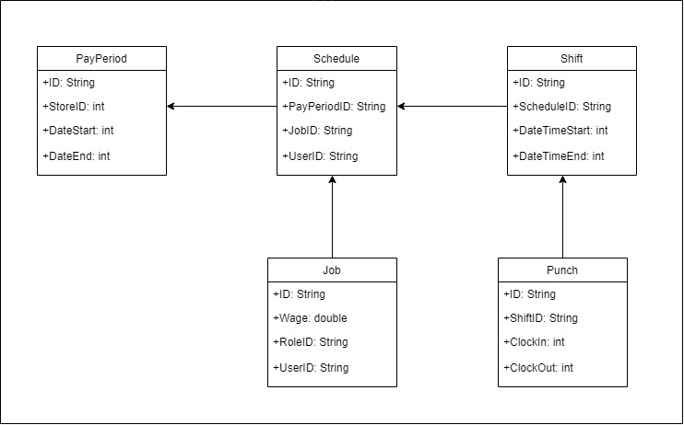

## Data dictionary

|  |  |  |  |
| --- | --- | --- | --- |
| Table Association | Name | Type | Description |
| PayPeriod | ID | String | Identifies the particular pay period |
| PayPeriod | StoreID | Int | Identifies the store at which the employee is working |
| PayPeriod | DateStart | int | The time at which an employee starts the shift. |
| PayPeriod | DateEnd | int | The time at which an employee endst the shift. |

|  |  |  |  |
| --- | --- | --- | --- |
| Table Association | Name | Type | Description |
| Schedule | ID | String | Identifies the particular schedule being viewed or edited. |
| Schedule | PayPeriodID | String | Identifies the particular pay period. |
| Schedule | JobID | String | Identifies the job the employee is performing for a given shift. |
| Schedule | UserID | String | Identifies the specific employee on the schedule. |

|  |  |  |  |
| --- | --- | --- | --- |
| Table Association | Name | Type | Description |
| Shift | ID | String | Identifies the specific shift an employee is working . |
| Shift | ScheduleID | String | Identifies the particular schedule being viewed or edited. |
| Shift | DateTimeStart | int | The start time for a given shift displayed on the schedule. |
| Shift | DateTimeEnd | int | The end time for a given shift displayed on the schedule. |

|  |  |  |  |
| --- | --- | --- | --- |
| Table Association | Name | Type | Description |
| Job | ID | String | Identifies the job the employee is performing for a given shift. |
| Job | Wage | double | Amount paid for a given timeframe to an employee, such as per hour or per week for salary. |
| Job | RoleID | string | Verifies the role an employee is performing during a given shift. |
| Job | UserID | String | Identifies the specific employee on the schedule. |

|  |  |  |  |
| --- | --- | --- | --- |
| Table Association | Name | Type | Description |
| Punch | ID | String | Represents the timeclock used by the employee to verify time in and time out for a shift. |
| Punch | ShiftID | String | Identifies the specific shift an employee is working. |
| Punch | ClockIn | int | Time at which an employee clocks in for the shift. |
| Punch | ClockOut | int | Time at which an employee clocks out for the shift. |

## Coding

### Approach (Functional, OOP)

Using Angular to create the frontend, there are aspects of functional programming, but Angular uses mostly object oriented programming, making it more appealing to users of C# and Java. The scheduling subsystem makes use of the object oriented aspect of Angular.

### Language

The language of Angular is Typescript, a more robust version of Javascript. Typescript compiles to Javascript, but helps to eliminate errors during the process of writing the code. As we are creating the front end of the application in Angular, the scheduling subsystem is written in Typescript.

## User training

### Training / User manual (needed for final report)

Upon logging in, the user is presented with a menu on the left side of the screen. One of the options is Scheduling. After choosing Scheduling, the user will be presented with a set of options dependent on his or her role.

Administrator (owner or manager):

The administrator page will have the following options:

View Schedule

Edit Schedule

View/Edit Payroll

Time Clock

User (employee):

The standard user page will have the following options:

View Schedule

View My Payroll

Time Clock

View Schedule:

The View Schedule option allows the user to view the current schedule.

Edit Schedule:

The Edit Schedule option allows an administrator to edit the current schedule

and create a new schedule.

View/Edit Payroll:

The View/Edit Payroll option allows an administrator to see and edit as necessary the payroll records. Options for editing include adding new employees, deleting old employees, as well as adjust wage information for each employee.

View My Payroll:

The View My Payroll option allows the user to view his payroll data, such as current wage information and paycheck totals.

Time Clock:

The Time Clock option used by any hourly employee to clock in and out of a particular shift.

## 

## 

# 8. Complete System

## Final software/hardware product

The final product will be a development version of a Point of Sales Suite that includes a completed API and DB backend, developmental editions of a Point of Sales subsystem, an Inventory Subsystem and a Scheduling subsystem.

## Source code and user manual – screenshots as needed - Technical report

<https://github.com/Michael-Calvo/Captsone-Spring2021>

## Evaluation by client and instructor

## Team Member Descriptions

### Richard Abrams

* + The inventory services serve as the communicator to the backend. It is where all REST API requests are made and any requests from external data are transferred from the service to the requestingcomponents.To help facilitate that, a transporter class was also created to serve as a generic container of data that can be utilized throughout the inventory to receive the data it needs. Utilizing both the inventory components will be to communicate with the backend and receive and send data as needed.

### Ronald Abrams

### Emily Ashburn

* + The Point of Sale subsystem facilitates the front of the house sales of this restaurant-based system. The views to be created within this system are mainly for the cashier/waiter/waitress/bartender roles, allowing the order of food off of the business’ menus, facilitating purchases, and displaying the view of the house and the available/taken/waiting-on-order seats.

### Mike Calvo

* + Users have been imported through google firebase. From there, their data is viewed on a profile landing page. If the person is not signed in, they cannot access the profiles tab. One there, the user can go back to the home page at any point using the profile tab. User is being implemented with the DB to find a matching user name and return their role and ID. This will be used to show which tabs users can access based on role.

### Jason Manning

* + The scheduling subsystem is used for the time clock function and viewing and creating an employee schedule. The time clock has basic functionality for employees to clock in and out and send the data to the database. The schedule views are separated by employment roles. Employees are able to see View Schedule whereas a manager can view Create Schedule and Edit Schedule as well.

### Ian Wilhelmsen

* + This subsystem is a no frills db and api backend with protections against sql injection attacks and api abuse. The subsystem supports ETL operations of the rest of the application. New instances of subsystems can be created still using this functionality. This release of the subsystem is stable for immediate release and needs of the application.